Manual for installation of touchscreen

I. Composition of Touchscreen

- One piece of glass panel: Touch carrier, mounted with wires and sensors.
- One piece of controller: Designed for detecting the touch on glass panel by finger or style pen, and sending touch data to host computer.
- One set of cables: Used for the connection between host computer, controller and glass panel.
- Drivers: Several versions of driver programs available for different operating system.
- Manual for touchscreen
II. How to install the controller

Two types of controllers are available, which are connected to serial port or USB port accordingly, i.e. 300LS and 300LU. Functions of jumper JP1 are given below (pins marked with odd numbers are located at the outside of circuit board):

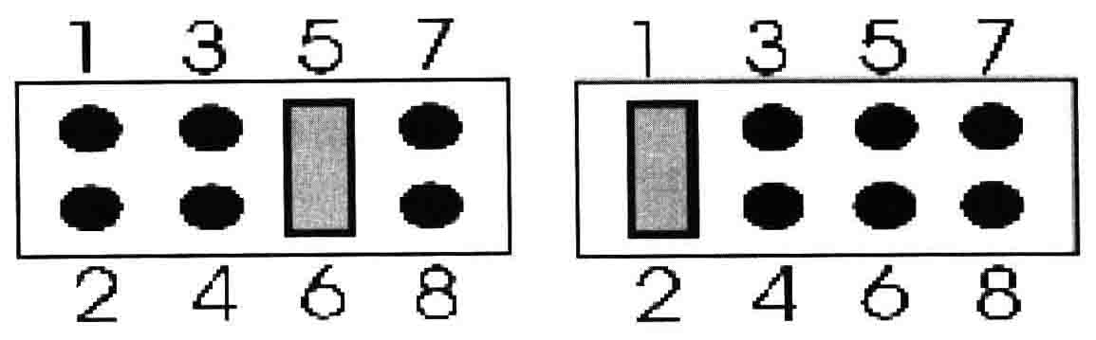

In case there is a jumper clip inserted between its pin 5 and pin 6, this indicates the controller is applicable to the glass panels smaller than 17″(17″ included)
In case there isn't a jumper clip inserted between its pin 5 and pin 6, this indicates that the controller is applicable to the glass panels larger than 17″(17″ excluded)
In case there is a jumper clip inserted between pin 1 and pin 2, this indicates normal operation mode. In this case our drivers must be used.
In case there isn’t a jumper clip inserted between pin 1 and pin 2, this indicates the controller is compatible with Microtouch operation mode. Drivers of Microtouch must be used. If your system used touchscreens from Microtouch
originally, you can replace with our touchscreens without any change to any part of original system, just let the jumper
between pin1 and pin2 open.
Controller can be fit inside the monitor or at its rear. In the following, we take a serial-port controller assembled inside the monitor as an example to present the assembling method.
(1) Stick a piece of double-faced rubberized tape onto the back of the controller, stick the other side of the double-faced tape onto the right-hand inner wall of rear cover of the monitor, with the plug facing the kinescope.
(2) Connect the cables properly.
Cable should be connected as shown in figure below:

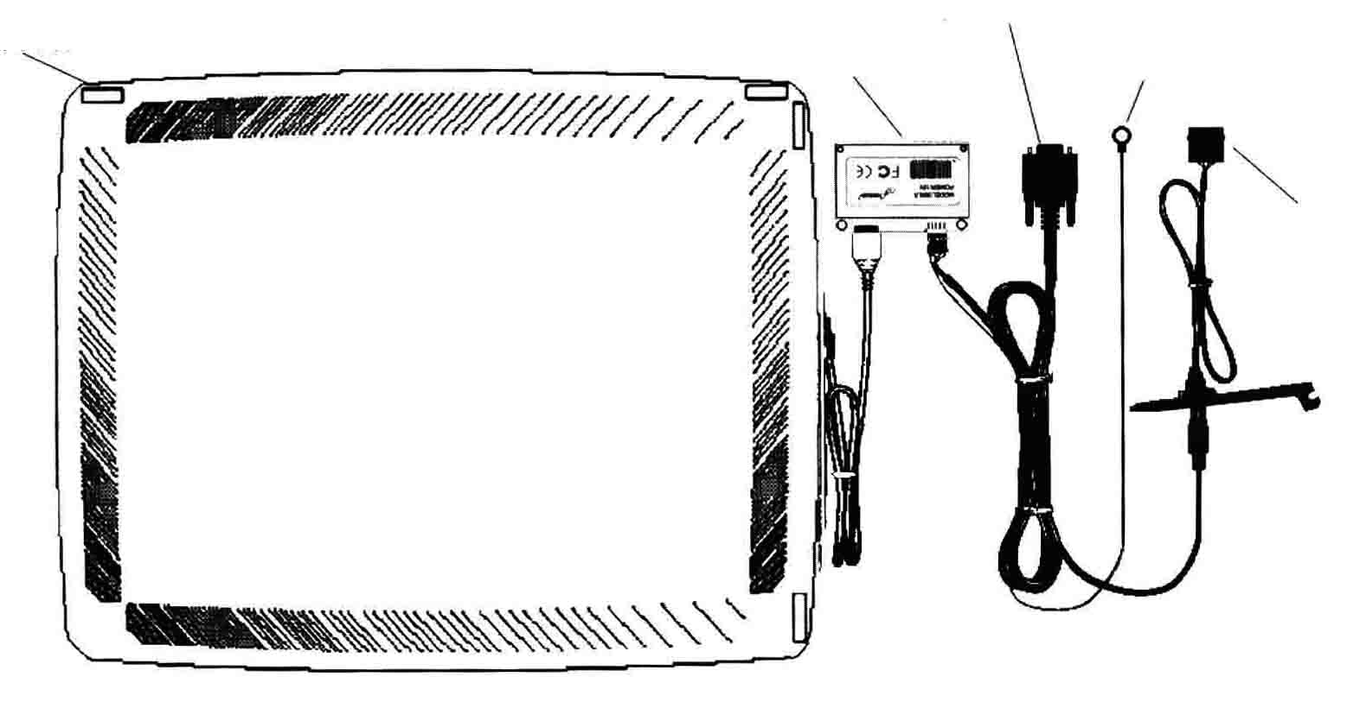
Glass panel
To serial port of computer
Controller
To Ground wire of kinescope
To power supply +12V of computer

- Insert the cable from glass panel into the interface for glass panel in controller. The cable plug has two pin rows, with 4 upper pins and 6 lower pins; and the direction is nonreversible.
- Connect the serial-port wire into the serial port interface of the controller, and the serial-port wire adopts either 2-row 5-pin or single-row 8-pin structure. In case it adopts 2×5 pin structure, 4 pins of the upper row and 2 pins of the lower row are valid, and the direction is non-reversible. One green wire among the serial-port wires serves as ground wire, and the green wire should be connected to the ground wire of kinescope so as to suppress interference.
- Tie down the cables such as serial-port wire and ground wire etc. with binding tape so as to ensure the compactness and esthetic appearance.
- Make a cable outlet. You may use an electrical drill or diagonal pliers to work out a outlet for communication cable in the side face or rear of the rear cover of monitor. Position of the outlet should ensure that cable outreaches it must not affect the reassembly of rear cover of monitor, and its size should be just adequate for passing through the cable and controller connector.

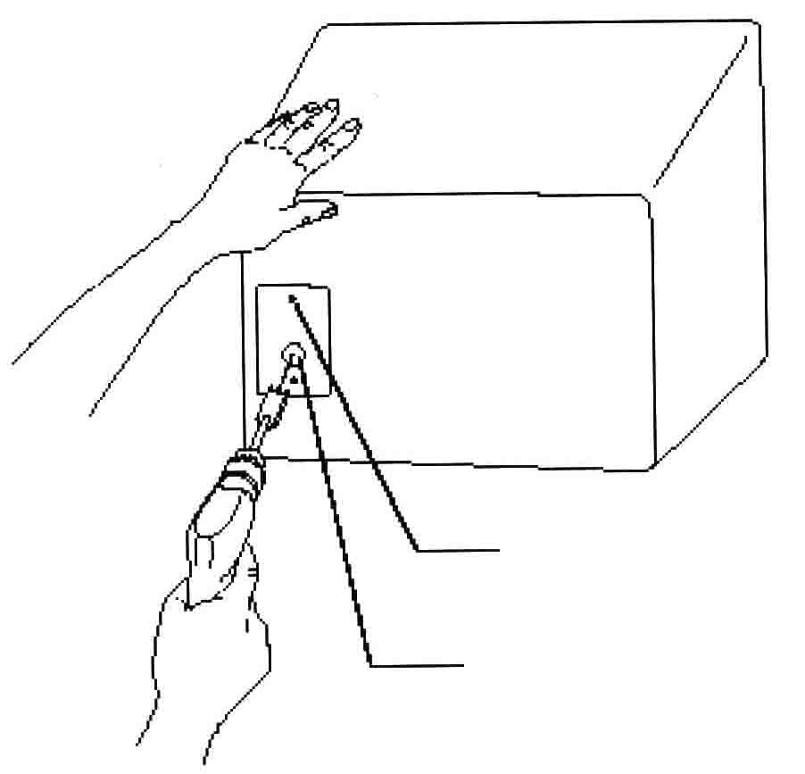

Two screw holes (one upper/lower each)

This hole is designed for passing through the touchscreen cable.

(4) Reassemble the monitor
This includes video board assembling, cable connection, rear cover reassembly, and front cover reposition. Tighten the attaching screws for rear cover.

III. Precautions for installation of hardware
(1) All power supply should be cut off in the whole process of assembly.
(2) Safety of glass panel
Normal glass panel is fragile, it must be handled with care, and the following condition should be observed:
- Take it up or put it down gently; prevent it from rubbing against high-hardness object such as metal, sandstone or glass etc. do not handle it unless the handling is necessary for the assembling.
- In case the clearance between the glass panel and monitor cover is too short, the inside part of monitor cover, which contacts the glass panel or is too much close to the glass panel, should be sanded with a sander so that the clearance between the glass panel and cover inside can be maintained over lmm.
- Owing to the fact that there are numerous manufacturer for monitors, many and diverse specifications, inaccuracy is allowable even in products of identical specification and manufactured by identical manufacturer, and radian discrepancy between glass panel and monitor is hard to avoid; in such a case, it is required to apply one more pass of double-faced tape so as to avoid the contacts between glass panel and surface of kinescope due to radian noncoincidence.
- The screws between the front cover and mounting lugs of kinescope must not be excessively fastened, all screws should be stressed on a rough average; Otherwise glass panel is possible to smeared or the kinescope surface may be damaged.
(3) Safety of the sensors
Sensor is a fragile and squashy part; sound wave is a type of mechanical vibration; keep any object from contacting the sensor for fear of either squashing or malfunction; to ensure the safety of the sensor, the following items should be observed:
- Avoid heavy pressure carefully; sensors should be kept away from contact with any other object after assembly is finished.
- Strengthening rib of the monitor cover, which lays close to the sensor, should be scissored off, and worn flat by rasper or sander.
- In case the height of edge lug on inner side of the monitor cover is inadequate, it is required to stick dust excluder onto the lug so as to ensure adequate height and protect the sensors properly.
- The screws between the front cover and mounting lugs of kinescope must not be excessively fastened, all screws should be stressed on a rough average; otherwise the sensors may be broken.
(4) Safety of controller
Pay attention to two points: firstly prevent the controller from contacting the electronic parts inside the kinescope,
for fear of damage to equipment due to short circuit or electric shock, which may results in interference that may
cause malfunction of touchscreen or the monitor; secondly ensure secure mounting, put an end to the possibility of
anything dropping into monitor due to unsecured mounting.
(5) Cable protection
The touch panel is assembled inside the monitor cover, the strengthening rib of the cover, which lays close to the signal wire at the edge of the touch panel should be scissored off and worn flat so as to prevent it from cut off or damage the cable. Cables plug must be connected securely, for fear of possible malfunction or untouchability of the touchscreen.
(6) Mount the dust excluder
Dust excluder is prone to distortion after tightening up; Therefore dust excluder should be assembled 1mm away from the edge of visual area of the monitor cover, such that the dust excluder may not get into the visual area if any deformation happens.

IV. Installation of driver programs

Different operating system requires different driver programs, and driver-program installation methods for WINDOWS System are almost identical. In the following, we will represent these as per two types of installation namely WINDOWS and DOS.
A. Installation of driver programs in WINDOWS System
We take WINDOWS 98/ me as examples:
1. Install the driver programs into the system
(1) Firstly prepare the driver programs, which may be on either floppy disk, U-disc, CD or Hard disk.
(2) Open the folder for placement of driver programs for WINDOWS 98/me Version, double click “Install”, and the screen displays:

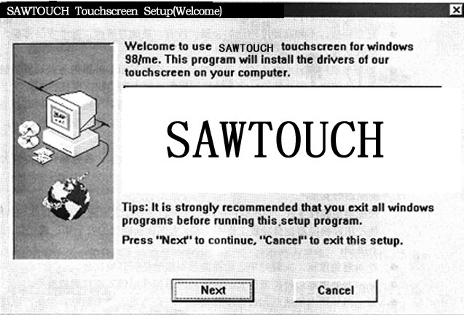

Press “Cancel” to terminate the installation, or press “Next” to continue the installation , and it displays:
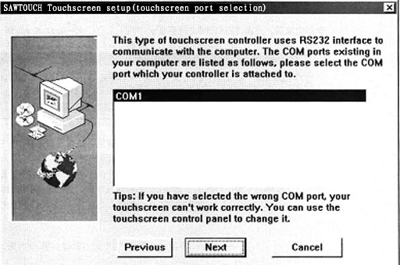

The COM port equipped on the host computer will be displayed inside the rectangular box, and move the cursor to the COM port connected to the touchscreen controller and click it.
Press “Previous” to return to the previous interface, press “Cancel” to terminate the installation, or press “Next” to continue the installation, and it displays:

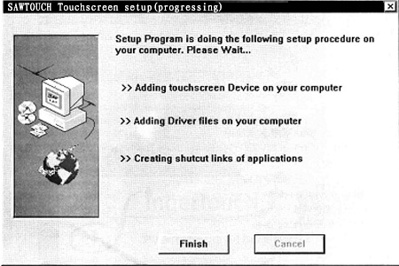

Programs of Installation will fulfill the displayed installation tasks one by one, and you may press “Cancel” to exit installation in the process of fulfillment.
Once all are finished, click “Finish”, and the screen displays:
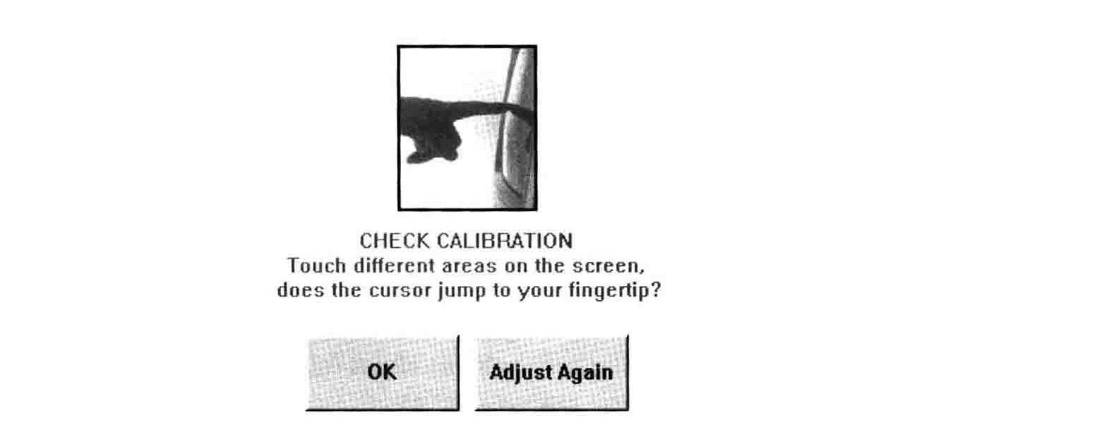
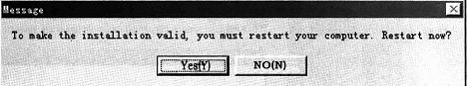

Press “Y” to restart the computer, or press “N” not to restart it. To validate the installation, you have to restart the computer; after restarting, it accesses to the calibration interface.
Let your finger point to the “＋” mark, and you may slightly shift the position of fine-tune touch before your finger is pointed to it exactly. After you pressed the “＋” mark, you may check if the calibration is correct or not in the screen (touch the screen as you please so as to check if the positions of the cursor and finger can coincide). If the calibration is correct, click “OK” for exit; otherwise click “Adjust Again” for calibration over again.

2. Functions of the driver programs
Point and click “Start” → “Program” → “SAWTOUCH Touchscreen” for 6 functions:

(1) Calibration
The method is the same as that mentioned in paragraph for installation.

(2) SAWTOUCH help
Help information.

(3) Handwriting demo
A small program for demonstration of touch effects, including touch force.

(4) Readme
Some information about the driver programs.
(5) Right Button
In “Drag, Double Click” mode, Right Button function is valid, and the method is given below:
(i) Click “Start”—“Programs”—“ SAWTOUCH Touchscreen”—“Right Button”, icon of Right Button is displayed at the upper left corner of the screen, and this icon may be drawn to any position on the screen.
(ii) Before right-click, firstly touch the right button icon, then touch the item to be right-clicked.
(iii) Point and click “X” mark in right button icon, you may cancel right button operation.
- Uninstall SAWTOUCH Uninstall operation. click this column, and the screen displays:

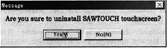

Press “N” to stop uninstallation, or press “Y” to continue, and it displays:

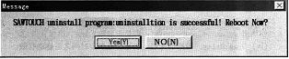

Press “N” to terminate uninstall, or press “Y” to restart computer; to validate uninstallation completely, you must restart the computer.
3. Setting of Parameters
Access to “control panel”, double click “SAWTOUCH”, and the screen displays:
Properties

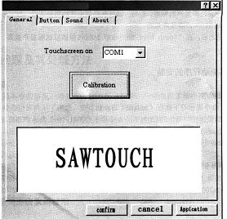

There are 4 items named “General”, “Button”, “Sound” and “About”; “About” only displays some version information, and the functions of other items are given below:
(1) General. It may set two objects: serial port and calibration of touchscreen, and the calibration method is the same as that mentioned in the paragraph for installation.
(2) Button. It may set four items:
(i) Mouse button emulation mode, and 4 kinds of modes as below:

Click on Touch: Be valid at once after touch; invalid if the finger moves before it is released from the screen after touch. Only the left button is valid, it does not support right button and drag operation. This mode is applicable to Kiosk.
Click on release: Touch is not valid until the finger is released from the screen; after finger touches, it allows your finger to move and adjust the touch position before your finger is released from the screen, and it is applicable to touch of small objects. Only the left button is valid, it does not support right button or drag operation.
Drag: Once your finger touch the screen and stick to it, this functions as you press and hold the left button of mouse, and you may drag as you like unless your finger is released from the screen. It support left button and drag operation, but it does not support right button.
Drag, Double Click: Support right button and double click, and others same as in Drag mode. Double-click area adjustment is valid in this mode only. This mode is most common.
(ii) Double Click area (10-100), it indicates the maximum distance between the previous and next touch points allowed by double click operation.
(iii) Hide arrow mouse point, namely if you want to hide the cursor or not.
(iv) Drag Delay, it indicates the time delay before a drag can be valid.
(3) Sound, voice adjustment, it has the following adjustment items:
(i) Enable Click Sound, namely if the sound is on.
(ii) Beep on touch release | You may select either “Beep on release” or “beep on touch”.  If you select “Beep on touch”, sound is produced once your finger touches the screen; if you select “Beep on release”, sound is produced after your finger is released from screen.

(iii) Tone, namely frequency of sound.
(iv) Duration, namely duration of sound.
Once adjustment is over, you may touch and touch the “Touch here to test” area so as to try the sound effect.

B. Installation of driver programs in DOS Version
1. Load the driver program
Execute under DOS command prompt: Ctmouse /Sn /T.
/Sn for assigning the COM port to which the touchscreen controller is connected, n=1 indicates COM 1; n=2 indicates
COM 2, and the rest reason by analogy.
/T indicates that the driver programs support SAWTOUCH Touchscreen.
For instance: ctmouse /S1 /T indicates DOS driver programs loading, and the touchscreen is connected to COM 1 port.
2. Calibration
Execute under DOS command prompt :gratouch m n
Of which m and n are positive integers, which separately indicates the number of transverse and lognitudinal pixels of the screen; m*n indicates the resolution of screen. Presently it supports the resolutions such as 640x200, 640x350, and 640x480 etc. Here we take 640x480 as an example, and the commands are given as below:
gratouch 640 480
Here, “+” is displayed in top left corner of the screen; once your finger touches the central position of the “＋” symbol, “+” in top left corner of the screen disappears, “+”is displayed in the right lower corner; once your finger touches the central position of the “＋” symbol, the screen displays:
touch different area of screen
the cursor should move to where you touch
Press SPACE to try again, other keys to exit
Here, you may check the effect of calibration. Touch different positions on the screen so as to check if the cursor coincides the touch points; if not, press SPACE key for calibration over again; if the calibration is errorless, press other key for exit.
3. Setting of parameter
Setmouse command is used for setting of parameters, and its format is as follows:
setmouse MouseMode il BeepMode i2 DragDelay i3 BeepFreq i4 Beeplen i5
i1-i5 is positive integer. Setmouse command may set 5 types of parameters, such as MouseMode, BeepMode, DragDelay, BeepFreq, BeepLen; you may set all these 5 types of parameters, or set one or several types of them at one time. Meanings of the parameters are given below:
MouseMode il, is equivalent to Mouse Button Emulation Mode of WINDOWS’s:
il=1: Click on touch
il=2: Click on release
il=3: Drag
BeepMode i2 is used for setting if you want sound or not when touching; if you select YES for sound, you still have to select “Beep on touch” or “Beep on release”:
i2 =1 No beep ,No sound when touching.
i2 =2 Beep on touch , Beep is given out once you touch the screen.
i2 =3 Beep on release ,Beep is given out after your finger is released from the screen
DragDelay i3, When MouseMode is in Drag mode, it may set the time interval before the dragging operation is regarded as valid,i3=1-255.
BeepFreq i4, it is used for setting the beep frequency, i4=200-20000
BeepLen i5, it is used for setting the beep length when touching, i5=1-1000

4. Uninstall
ctmouse /u : used for uninstall the driver programs from DOS System.

V. Frequent asked questions and relevant process
1. Touch inaccuracy
In case of touch inaccuracy, please go to calibration; in a general way, the problem may be solved by recalibration. If not, the following situations are possible:
(1) There are water droplets, oil stain or other materials capable of absorbing surface acoustic wave on the surface of touchscreen; or there are other objects around the touchscreen may contact or press the touchscreen, this causes controller misjudgement, resulting in inaccuracy. A great many materials may absorb surface acoustic wave, such as water, oil etc. these may affect the touchscreen in the mode as touched by finger, interfere correct judgment of touch, resulting in inaccuracy.
(2) Parts of the reflecting stripes of touchscreen are damaged, which cannot be recovered easily. As an expedient measure, you may carry out calibration positioning of “＋”mark at a reverse equidistant away from the mouse so as to achieve the effect of normal touch.
- Controller malfunctions, just replace the controller.

2. Recalibration should be carried out in case the following phenomena occur:

(1) Monitor or computer system was replaced.
(2) Display mode of the monitor is changed.
- Controller is replaced.

3. Touch on some positions of touchscreen causes no response or the response is slow
The first possible cause is that some reflecting stripes are covered, or there are water droplets or oil stain etc. on the surface; another possible cause is that Jumper JP1 of controller is set incorrectly; the third possible cause is that some reflecting stripes are damaged.

4. Too long response time for touch
This phenomenon may be caused by too low speed of host computer or dirt on the surface of panel; please replace the host computer or clean the surface of panel.

5. Touchscreen does not work
Possible cause may be misapplication or hardware fault.
- Firstly check if the surface of glass panel is covered or pressed on by dirt or other materials, if yes, clean the surface firstly; put an end to any surface contact.

- Check if the cable is securely connected correctly.

(3) Turn on the power supply. If no touch occurs, controller indicator will be on for 4-5 seconds before it is off; after that, it will be on only in case any touch occurs, and off if no touch occurs. If so, it is normal; if not so, it must be faulty;
(i) Indicator cannot be on. Firstly check if the power supply and connecting wires are normal; if yes, the controller malfunctions surely.
(ii) Indicator flickers. This may be caused by damage on panel, abnormal cable or controller malfunction. If you have normal spare hard ware for touchscreen, you may replace the parts and determine the faulty parts.
(iii) Indicator is constantly on when no touch occurs. Usually, this may be caused by controller malfunction, or sensor, panel or cable.

(4) If the controller indicator is all well, but no response after touch, then
(i) Check if the driver programs in the computer system have been installed, or installed properly.
(ii) If the controller is equipped with serial port, check if the set serial port is in consonance with the serial port that is actually connected to the serial port cable; if not, reset it.
(iii) If the controller is equipped with serial port, check if there is any collision of the serial port resources, especially the IRQ settings; if the IRQ used in serial port in collision with IRQ used in other equipment, just select other inactive IRQ, or just turn off other equipment in collision.

